Neapolitan Network
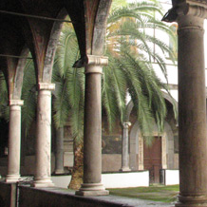
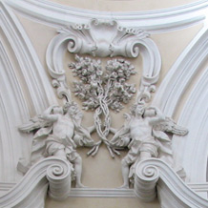
Founded by Melissa Calaresu (Gonville and Caius College, Cambridge) and Helen Hills (University of York):

- draws together Neapolitanists from around the world

- supports interdisciplinary and adventurous research on Naples (broadly defined)

- facilitates academic exchange, meetings, conferences, and research projects focused on Naples, including city and Kingdom, and related research topics

- publicizes new publications, conferences, events.

Join the Neapolitan Network
Visit the website

